
GYM MANAGEMET
Business Requirements Document

ENG. AHMED EMAM
PREPARED BY

1️⃣ Minimal Business Features (MVP Scope)
This version is what a small–medium gym needs on day one.

🧍 Member Management (Essential)
- Add / edit / deactivate members
- Membership start & end dates
- Membership status (Active / Expired)
- Basic profile data (name, phone, email)

🏋️ Trainer Management (Basic)
- Add trainers
- Assign trainer to a session
- Trainer availability (simple time ranges)

📅 Sessions (Classes)
- Create session (date, time, capacity)
- Assign trainer
- Session status (Open / Full)

📌 Booking
- Member books a session
- Prevent overbooking
- Cancel booking

💳 Membership Plans
- Define plans (Monthly / Yearly)
- Max sessions per plan
- Price

👮 Authentication & Roles
- Login
- Roles:
  - Admin
  - Trainer
  - Member

📊 Very Basic Reports
- Active members count
- Sessions per day
- Bookings per session

2️⃣ Final Tech Stack
Platform
- .NET 10
- ASP.NET Core Web API

Architecture
- Onion Architecture
- Clear separation between Domain, Application, Infrastructure, and API layers

Data Access
- Entity Framework Core
- SQL Server
- Code-First approach
- Fluent API for entity configuration

Mapping
- AutoMapper
- Feature-based mapping profiles

Validation
- FluentValidation
- Request-level validation integrated into the pipeline

Persistence Patterns
- Repository Pattern
- Unit of Work
- One DbContext acting as a single transactional boundary

Authentication & Authorization
- ASP.NET Core Identity
- JWT authentication
- Role-based authorization

Logging
- ILogger<T>
- Structured application and request logging
- Centralized logging via middleware

Error Handling
- Global exception handling middleware
- Consistent API response model

API Documentation
- Swagger / OpenAPI
- JWT support inside Swagger UI

3️⃣ Project Structure (Onion)
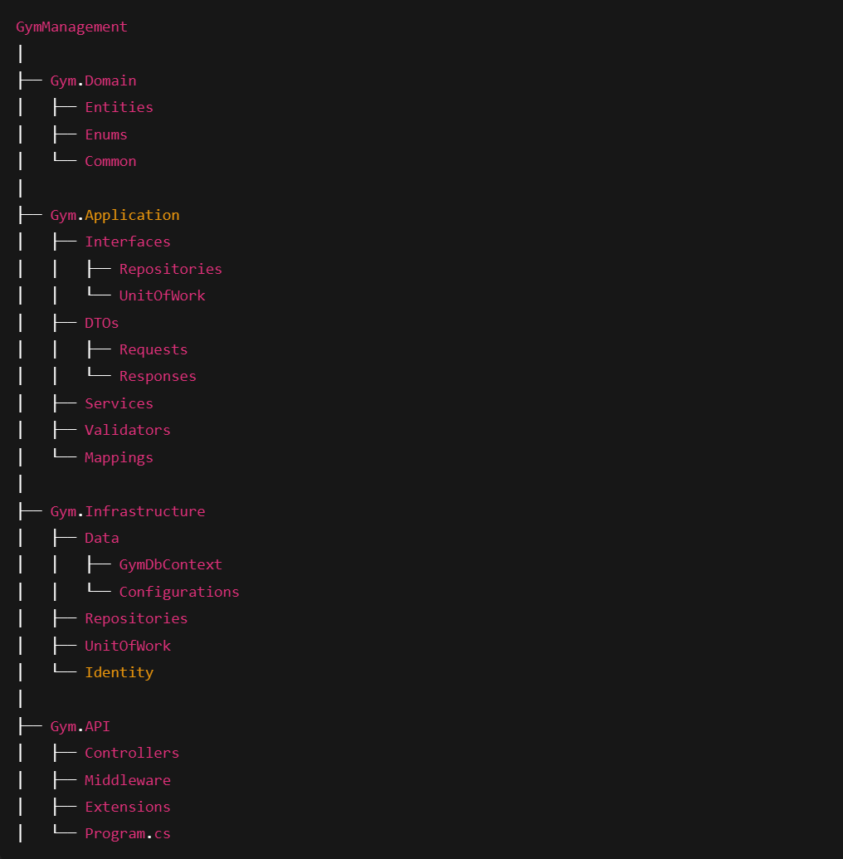
4️⃣ Core Domain Entities
Member
- Id
- FullName
- Phone
- Email
- MembershipPlanId
- StartDate
- EndDate
- Status
Trainer
- Id
- FullName
- Specialty
Session
- Id
- Title
- Date
- StartTime
- Capacity
- TrainerId
Booking
- Id
- MemberId
- SessionId
- BookingDate
MembershipPlan
- Id
- Name
- Price
- MaxSessionsPerMonth

5️⃣ Repository & Unit of Work Design
Generic Repository
- GetByIdAsync
- GetAllAsync
- AddAsync
- Update
- Remove

Unit of Work
- Members
- Trainers
- Sessions
- Bookings
- MembershipPlans
- SaveChangesAsync

6️⃣ FluentValidation Strategy
- Validators per request model
- Centralized rule definitions
- Automatic execution in the request pipeline

7️⃣ AutoMapper Strategy
- One mapping profile per feature
- Clear Entity ↔ DTO transformations
- Mapping focused purely on data shape

8️⃣ Logging Strategy (ILogger)
- Application lifecycle logging
- Request and response logging via middleware
- Error and exception logging with structured context

9️⃣ Why This Setup Works
- Uses modern .NET 10
- Follows a clean, scalable architecture
- Simple enough for an MVP and strong enough for production
- Easy to extend with additional modules and integrations

